AYAN BHOWAL 20BCE2875

Cardiac Disease Prediction using Arduino and Advanced Neural Network Model

1. **Abstract**

Remote healthcare services have become essential for healthcare providers and health device manufacturers. To offer such services, they require specialized health devices that can collect, store, and transmit various human bio-signals. These devices should be capable of functioning for both short-term and long-term basis. Since the advent of Information Technology, the traditional paper-based methods of data collection have become outdated. These techniques are difficult to analyze, monitor, and extract data from. Furthermore, these old techniques do not allow for the storage and tracking of different patient's health status. In contrast, keeping a record of a patient's medical history is crucial for monitoring their overall health status.

1. **Introduction**

For many healthcare service providers and medical device makers, remote healthcare services are becoming essential. This method needs specialised medical equipment that can receive, store, and send a variety of human bio-signals at either a short- or long-term rate.

Since IT renaissance, traditional paper-based ways of data collection became a non-preferred utility due to hard analysis, monitoring, or even data extraction procedures, these old technics does not enable data storage to keep track of different patient’s health status. In the meanwhile, historical patient status plays an important role for patient’s overall status monitoring.

Advanced healthcare devices like Apple iWatch4, Sanatmetal WIWE, present some of nowadays’ healthcare technologies that could keep track of patient’s health status during all day activities. These devices could work for many hours, days, or even weeks depending on the device, hence, it enables continuous patient’s vital signs monitoring.

1. **Literature Survey**

R. Richer, T. Maiwald, C. Pasluosta, B. Hensel and B. M. Eskofier, "Novel human computer interaction principles for cardiac feedback using google glass and Android wear," 2015 IEEE 12th International Conference on Wearable and Implantable Body Sensor Networks (BSN), Cambridge, MA, USA, 2015, pp. 1-6,doi: 10.1109/BSN.2015.7299363.

The paper presents a novel approach to cardiac feedback using wearable technology, specifically Google Glass and Android Wear. The authors discuss the development of a cardiac feedback system that provides real-time feedback to the user using visual, auditory, and tactile cues. The paper demonstrates the feasibility of using wearable technology for cardiac feedback and provides insights into the potential applications of this technology in healthcare.

BENHAMIDA and M. KOZLOVSZKY, "Human ECG data collection, digitalization, streaming and storing," 2020 IEEE 18th World Symposium on Applied Machine Intelligence and Informatics (SAMI), Herlany, Slovakia, 2020, pp. 105-110, doi: 10.1109/SAMI48414.2020.9108765.

The paper focuses on the process of collecting and storing human ECG data, which is used for various medical purposes. The authors discuss the digitalization of ECG data, including the hardware and software used for recording and processing the data.

The paper also presents different methods for streaming and storing ECG data, including cloud-based solutions and local storage. The authors also discuss the challenges and limitations of collecting and processing ECG data, including issues related to data privacy, security, and data quality.In addition to providing a comprehensive overview of ECG data collection and processing, the paper also presents a case study of ECG data collection and processing in a clinical setting. The authors discuss the hardware and software used for collecting and processing ECG data, as well as the challenges and limitations faced during the process. Overall, the paper provides valuable insights into the process of collecting and processing ECG data and the challenges and limitations associated with it. It is a useful resource for researchers and practitioners working in the

field of medical data collection and analysis.

C. K. Chang and K. Oyama, "Guest Editorial: A Roadmap for Mobile and Cloud Services for Digital Health," in IEEE Transactions on Services Computing, vol. 11, no. 2, pp. 232-235, 1 March-April 2018, doi: 10.1109/TSC.2017.2778658.

The paper provides a roadmap for mobile and cloud services in digital health. It highlights the importance of digital health in modern healthcare and provides insights into the latest developments in mobile and cloud services. The authors discuss the challenges and opportunities of digital health and outline the roadmap for the development of mobile and cloud services for digital health. The paper is a useful resource for researchers and practitioners in the field of digital health.

S. M. R. Islam, D. Kwak, M. H. Kabir, M. Hossain and K. -S. Kwak, "The Internet of Things for Health Care: A Comprehensive Survey," in IEEE Access, vol. 3, pp. 678-708, 2015, doi: 10.1109/ACCESS.2015.2437951.

The paper presents a comprehensive survey of the use of the Internet of Things (IoT) in

healthcare. The authors discuss the various applications of IoT in healthcare, including patient monitoring, disease management, and medical equipment management. They also review the challenges and limitations associated with the use of IoT in healthcare, such as data privacy and security concerns. Overall, the paper provides a valuable overview of the potential uses and challenges of IoT in healthcare.

Jindal, Harshit & Agrawal, Sarthak & Khera, Rishabh & Jain, Rachna & Nagrath, Preeti. (2021). Heart disease prediction using machine learning algorithms. IOP Conference Series: Materials Science and Engineering. 1022. 012072. 10.1088/1757-899X/1022/1/012072.

The authors reviewed several studies that have used different machine learning algorithms for heart disease prediction, including decision tree, random forest, support vector machine, logistic regression, and artificial neural networks. They observed that most of the studies had used public datasets such as the Cleveland dataset, the Hungarian dataset, and the Statlog dataset for their research. The authors also discussed the features used in heart disease prediction, including age, sex, chest pain type, resting blood pressure, serum cholesterol levels, fasting blood sugar levels, electrocardiogram results, and exercise-induced angina. They highlighted the importance of feature selection in improving the accuracy of machine learning algorithms for heart disease prediction.In their own research, the authors used the Cleveland dataset and compared the performance of different machine learning algorithms for heart disease prediction. They found that the random forest algorithm had the highest accuracy of 85.25%, followed by the artificial neural network with an accuracy of 84.42%. Overall, the article provides a comprehensive literature survey on the application of machine learning algorithms in heart disease prediction and presents new results that could be useful for future research in this area.

Yazdani, A., Varathan, K.D., Chiam, Y.K. et al. A novel approach for heart disease prediction using strength scores with significant predictors. BMC Med Inform Decis Mak **21**, 194 (2021). <https://doi.org/10.1186/s12911-021-01527-5>

This article presents a new method for predicting heart disease using a combination of strength scores and significant predictors. The article was published in BMC Medical Informatics and Decision Making in 2021.The authors begin by discussing the importance of predicting heart disease, as it is the leading cause of death globally. They then review previous studies that have used various methods for heart disease prediction, such as logistic regression, decision trees, and neural networks. However, they note that these methods can be limited in their ability to handle complex data and identify important features.To address these limitations, the authors propose a novel approach that combines strength scores with significant predictors. Strength scores are calculated based on the correlation between each feature and the target variable, and are used to weight the contribution of each feature to the final prediction. Significant predictors are identified using a feature selection algorithm.

The authors then describe their methodology in detail, including the dataset used for training and testing the model, the feature selection algorithm, and the evaluation metrics used to assess the performance of the model. Results show that the proposed method outperforms several baseline models, achieving an accuracy of 0.83 and an AUC of 0.89. The authors also conduct a sensitivity analysis to evaluate the robustness of their approach.Overall, the article presents a promising new method for heart disease prediction that combines strength scores with significant predictors. However, further research is needed to validate the method on larger and more diverse datasets.

1. **Findings and Inferences from Literature Survey**

|  |  |  |
| --- | --- | --- |
| **Citation** | **Inference** | **Drawbacks** |
| R. Richer, T. Maiwald, C. Pasluosta, B. Hensel and B. M. Eskofier, "Novel human computer interaction principles for cardiac feedback using google glass and Android wear," 2015 IEEE 12th International Conference on Wearable and Implantable Body Sensor Networks (BSN), Cambridge, MA, USA, 2015, pp. 1-6, doi: 10.1109/BSN.2015.7299363. | The paper proposes a cardiac feedback system using Google Glass and Android Wear, which provides real-time feedback to the user using visual, auditory, and tactile cues, with potential applications in healthcare. | Some potential limitations of wearable devices for healthcare applications may include concerns around data security and privacy, battery life, comfort and usability, accuracy and reliability of sensors, and regulatory and ethical considerations. It is important for researchers and practitioners to address these challenges to ensure that wearable devices are effective and safe for use in healthcare settings. |
| C. K. Chang and K. Oyama, "Guest Editorial: A Roadmap for Mobile and Cloud Services for Digital Health," in IEEE Transactions on Services Computing, vol. 11, no. 2, pp. 232-235, 1 March-April 2018, doi: 10.1109/TSC.2017.2778658. | The paper provides a roadmap for the development of mobile and cloud services for digital health. The authors emphasize the importance of collaboration between industry, academia, and government to create effective and efficient digital health solutions. They also highlight the need for standardization and interoperability of digital health services to ensure their widespread adoption and usage. The paper provides valuable insights into the future of digital health and highlights the potential of mobile and cloud services in transforming healthcare. | It mentions some challenges and issues related to the use of mobile and cloud services for digital health, including data privacy and security, lack of standardization, and interoperability. The authors also discuss the need for better collaboration between different stakeholders, such as healthcare providers, technology vendors, and regulatory agencies, to address these challenges and to promote the widespread adoption of mobile and cloud services for digital health. |
| A. BENHAMIDA and M. KOZLOVSZKY, "Human ECG data collection, digitalization, streaming and storing," 2020 IEEE 18th World Symposium on Applied Machine Intelligence and Informatics (SAMI), Herlany, Slovakia, 2020, pp. 105-110, doi: 10.1109/SAMI48414.2020.9108765. | The paper provides an overview of the process of collecting and storing human ECG data, including digitalization, streaming, and storage methods, as well as the challenges and limitations associated with the process. It is a useful resource for medical data collection and analysis researchers and practitioners. | some potential limitations or challenges of this approach could include data security and privacy concerns, interoperability issues, technical challenges in ensuring reliable and accurate data collection and transmission, and the need for trained personnel to interpret and analyze the collected data. Additionally, the cost of implementing and maintaining such a system could be a potential drawback for some healthcare providers or institutions. |
| S. M. R. Islam, D. Kwak, M. H. Kabir, M. Hossain and K. -S. Kwak, "The Internet of Things for Health Care: A Comprehensive Survey," in IEEE Access, vol. 3, pp. 678-708, 2015, doi: 10.1109/ACCESS.2015.2437951. | The paper provides a survey of the use of the Internet of Things (IoT) in healthcare, covering applications, benefits, challenges, and future directions. It offers insights for researchers and practitioners in the field. | The paper identifies several drawbacks and challenges associated with the use of IoT in healthcare, including data security and privacy concerns, interoperability issues, regulatory barriers, ethical and legal issues, lack of standardization, and limited usability and user acceptance. The authors also note that the high cost of implementing IoT in healthcare can be a significant barrier to adoption, and that the complexity of IoT systems can make them difficult to manage and maintain. |

1. **Proposed System**

The Advanced Neural Network Model has been used in this project.

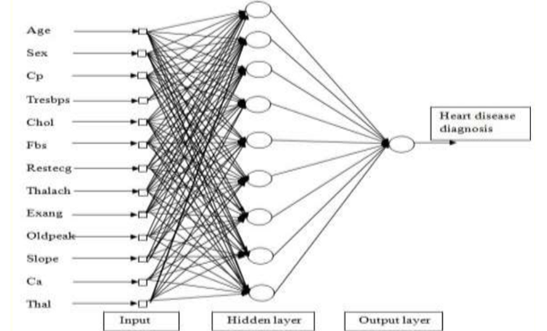

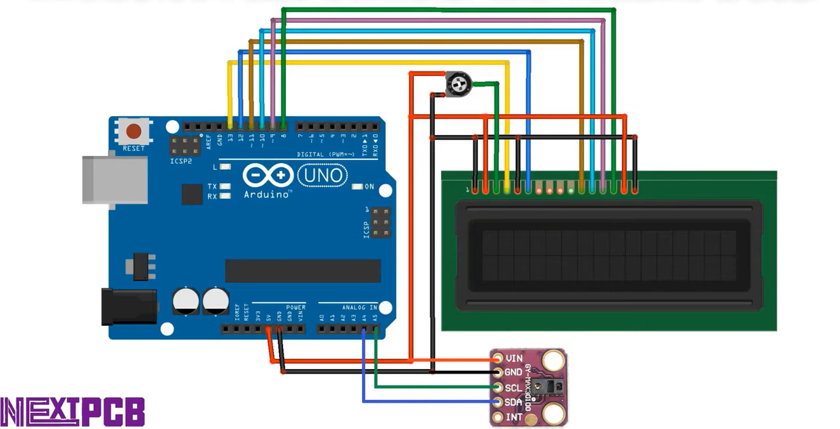

1. **Methodology/Procedure**
2. First of all we write the code in Arduino Ide
3. The code will be written in c++
4. The code will be as follows:

#include <LiquidCrystal.h>

#include <Wire.h>

#include "MAX30100_PulseOximeter.h"

LiquidCrystal lcd(13, 12, 11, 10, 9, 8);

#define REPORTING_PERIOD_MS 1000

PulseOximeter pox;

uint32_t tsLastReport = 0;

void onBeatDetected()

{

Serial.println("Beat!");

}

void setup()

{

Serial.begin(115200);

Serial.print("Initializing pulse oximeter..");

lcd.begin(16,2);

lcd.print("Initializing...");

delay(3000);

lcd.clear();

if (!pox.begin()) {

Serial.println("FAILED");

for(;;);

} else {

Serial.println("SUCCESS");

}

pox.setIRLedCurrent(MAX30100_LED_CURR_7_6MA);

pox.setOnBeatDetectedCallback(onBeatDetected);

}

void loop()

{

pox.update();

if (millis() - tsLastReport > REPORTING_PERIOD_MS) {

Serial.print("Heart rate:");

Serial.print(pox.getHeartRate());

Serial.print("bpm / SpO2:");

Serial.print(pox.getSpO2());

Serial.println("%");

lcd.clear();

lcd.setCursor(0,0);

lcd.print("BPM : ");

lcd.print(pox.getHeartRate());

lcd.setCursor(0,1);

lcd.print("SpO2: ");

lcd.print(pox.getSpO2());

lcd.print("%");

tsLastReport = millis();

}

}

d)Then we will set-up our Arduino board with the lcd display

e)The wiring will be done according to the figure No 3 given above

f)After wiring is completed we will be connecting our Wired and g)configured Arduino Board to our System.

h)We will select the port (in my case it is COM5) , through which we will push the code given above into the Arduino.

i)The Arduino will then read our code and give us the output.

j)We put the patient’s finger onto the MAX3010 sensor which sends the reading to the serial monitor on our system.

k)Then we go to our website (Hosted on Local Host Xampp Server)

l)Here the readings will already be listed on the website since we have connected the serial monitot.

m)We have to enter the following details regarding the patient’s health report.

n)The following fields have to entered for more accuracy:  
Age

gender

Blood Pressure

Cholesterol Levels

Blood Sugar Levels(mmol/L)

Family History

Smoking

Body Mass Index (BMI- kg/m2)

Exercise

Anemia

Creatinine Phosphokinase

Diabetes

Ejection Fraction

High Blood Pressure

Platelets

Serum Creatinine

Serum Sodium

o)In the website , we hit Predict button at the end which redirect’s us into another page where the Advanced Neural Network Model has been deployed and the data is being compared from the trained dataset.

p)After Analysis – the Graph Along with the Result will be made where 1 means – the patient has cardiac disease and 0 means the patient does not have cardiac disease.

1. **Experimental Setup (details about software, hardware used, network coverage area, etc)**
2. Software used : Windows 11
3. Hardware used [Components]

* Pulse oximeter spo2 sensor max 3010
* Dht11 temperature and humidity sensor
* Arduino microcontroller
* Connecting wires and breadboard
* Potentiometer

1. Network Coverage Area   
   Local Host used: Xampp and Apache Server
2. **Results and Discussion (parameters measured, parameters modified, graphs, etc )**

Parameters Used :

|  |  |
| --- | --- |
| SpO2 | Heart Rate Pulse |

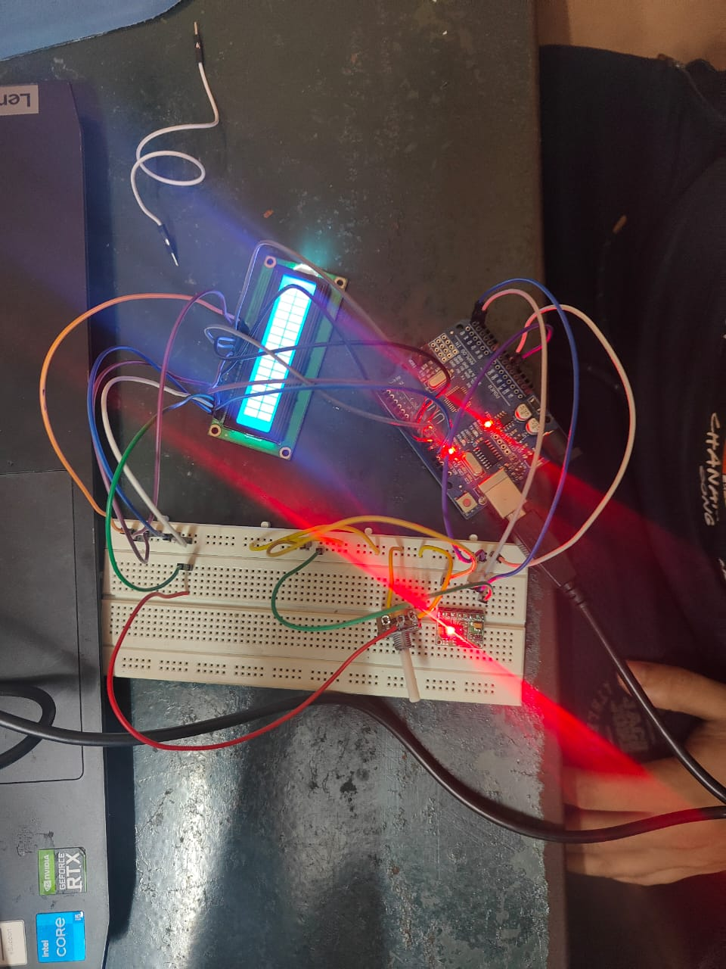



1. **Findings**

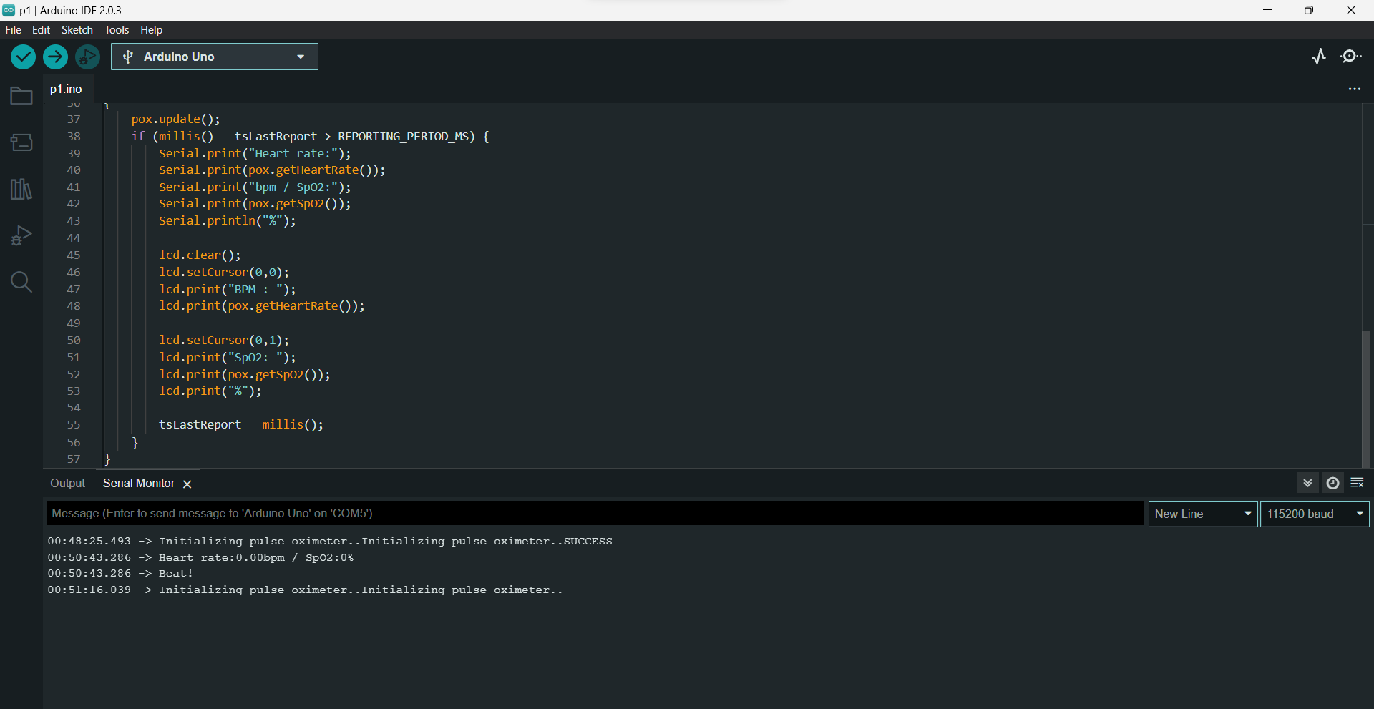

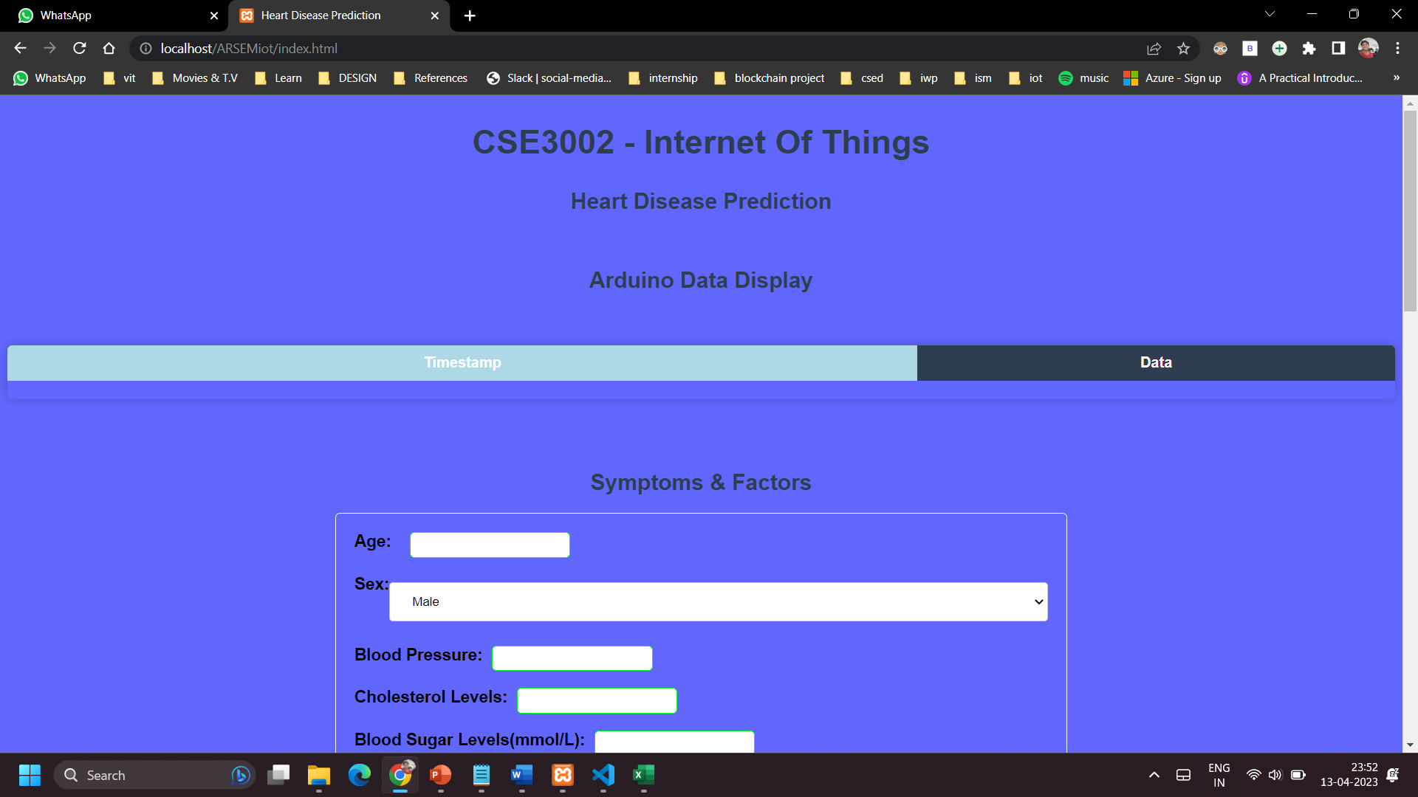

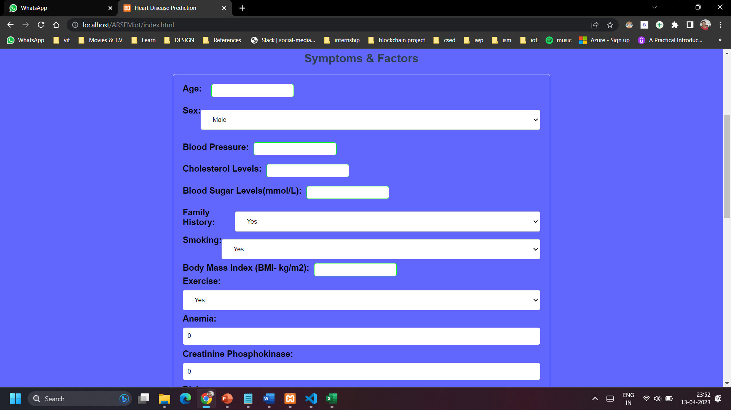

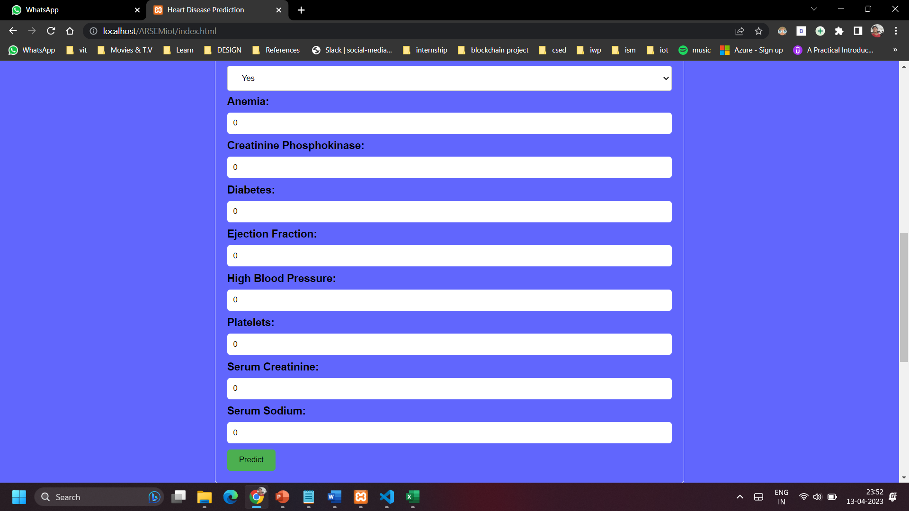

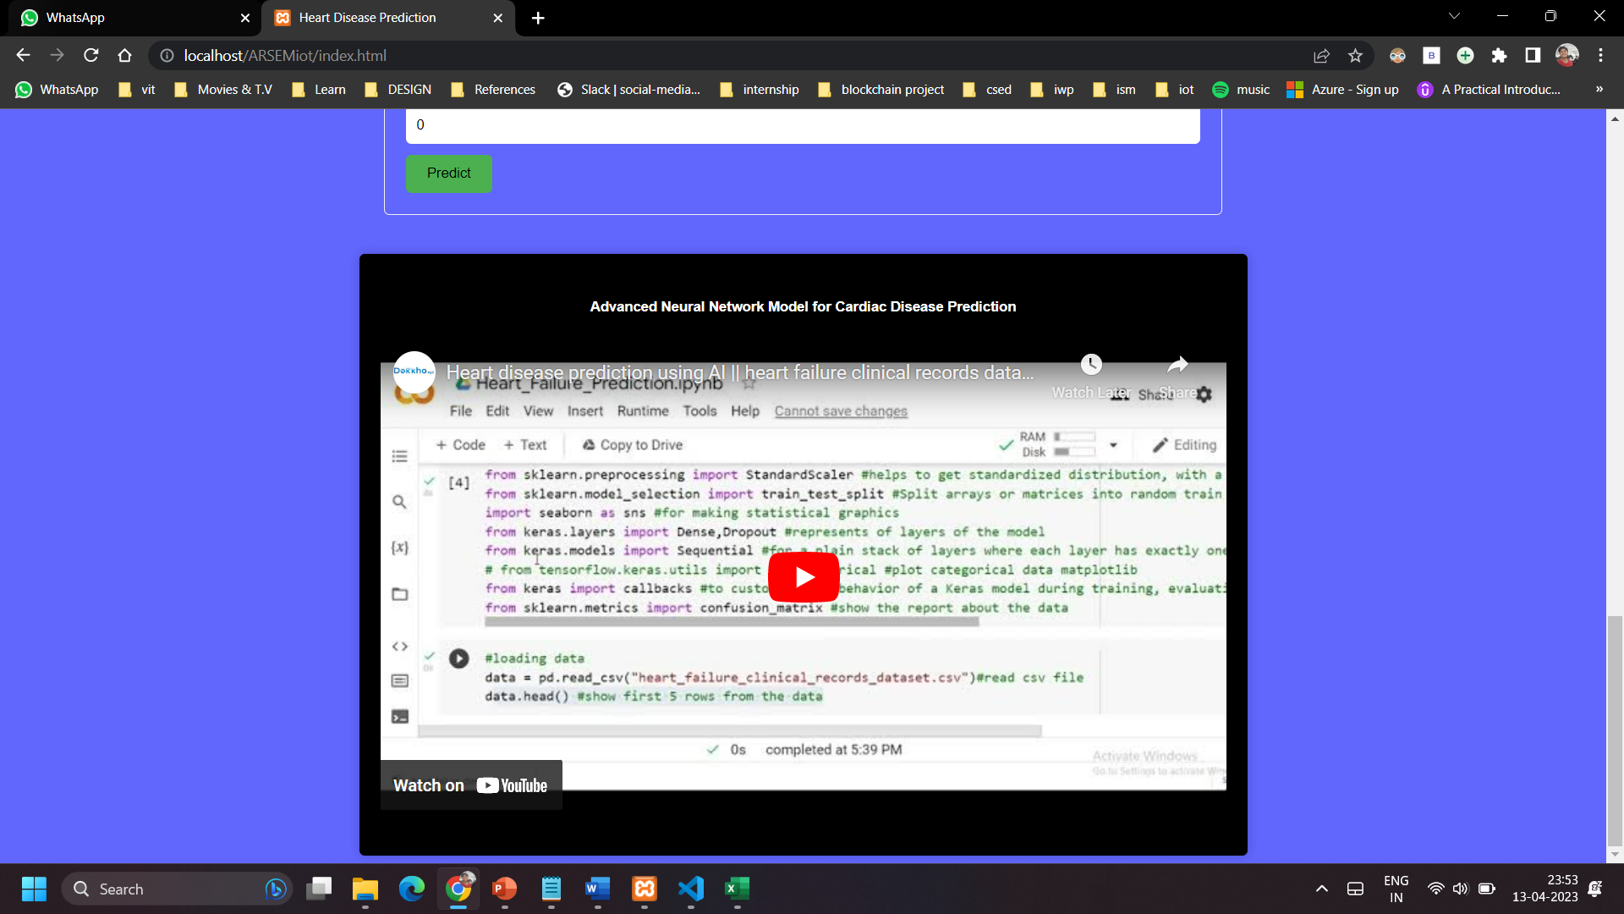

1. **Conclusions and Future Work**

This study has contributed to the achievement of the highest confidence score in heart disease prediction using important features in the ANN model. The allocation of appropriate weight scores has been found to enhance the confidence level performance in prediction. The heart disease prediction utilized a set of significant features with varying weights that reflect the strength of each feature.

Subsequent research may focus on predicting the risk levels of heart disease, which can aid medical professionals and patients in assessing the severity of heart disease. The weight measurement algorithm utilized in this study can be further examined for its applicability to other datasets in catering to additional prediction models that use a weighted approach. The machine learning techniques utilized in the feature selection phase of this study are restricted to the most commonly used techniques in heart disease prediction research. In the future, researchers should explore other machine learning techniques to select significant features.

You can access the documentation , codes and rest of the materials related to this project on my [Github profile](https://github.com/Bhowal19/UnitConvert) under the Repository :  
[Cardiac Disease Prediction Using Arduino](https://github.com/Bhowal19/Cardiac-Disease-Prediction-Using-Arduino)

I will be regularly updating this Github Repository for the Machine learning model and the dataset based from kaggle

1. **References/Bibliography**

R. Richer, T. Maiwald, C. Pasluosta, B. Hensel and B. M. Eskofier, "Novel human computer interaction principles for cardiac feedback using google glass and Android wear," 2015 IEEE 12th International Conference on Wearable and Implantable Body Sensor Networks (BSN), Cambridge, MA, USA, 2015, pp. 1-6, doi: 10.1109/BSN.2015.7299363.

A. BENHAMIDA and M. KOZLOVSZKY, "Human ECG data collection, digitalization, streaming and storing," 2020 IEEE 18th World Symposium on Applied Machine Intelligence and Informatics (SAMI), Herlany, Slovakia, 2020, pp. 105-110, doi: 10.1109/SAMI48414.2020.9108765.

C. K. Chang and K. Oyama, "Guest Editorial: A Roadmap for Mobile and Cloud Services for Digital Health," in IEEE Transactions on Services Computing, vol. 11, no. 2, pp. 232-235, 1 March-April 2018, doi: 10.1109/TSC.2017.2778658.

S. M. R. Islam, D. Kwak, M. H. Kabir, M. Hossain and K. -S. Kwak, "The Internet of Things for Health Care: A Comprehensive Survey," in IEEE Access, vol. 3, pp. 678-708, 2015, doi: 10.1109/ACCESS.2015.2437951.

Yazdani, A., Varathan, K.D., Chiam, Y.K. et al. A novel approach for heart disease prediction using strength scores with significant predictors. BMC Med Inform Decis Mak **21**, 194 (2021). <https://doi.org/10.1186/s12911-021-01527-5>

Jindal, Harshit & Agrawal, Sarthak & Khera, Rishabh & Jain, Rachna & Nagrath, Preeti. (2021). Heart disease prediction using machine learning algorithms. IOP Conference Series: Materials Science and Engineering. 1022. 012072. 10.1088/1757-899X/1022/1/012072.

1. Appendices

<https://www.researchgate.net/publication/348604625_Heart_disease_prediction_using_machine_learning_algorithms/citation/download>

<https://iopscience.iop.org/article/10.1088/1757-899X/1022/1/012072/meta>

<https://bmcmedinformdecismak.biomedcentral.com/articles/10.1186/s12911-021-01527-5#citeas>

<https://www.researchgate.net/publication/283016730_Novel_Human_Computer_Interaction_Principles_for_Cardiac_Feedback_using_Google_Glass_and_Android_Wear>

<https://www.kaggle.com/code/zohaib123/heart-disease-prediction-research-work>